**Experient-8**

**Data Link Layer Traffic Simulation using Packet Tracer Analysis of ARP.**

**Step1:**  1 switch,3 PCs and 1 server

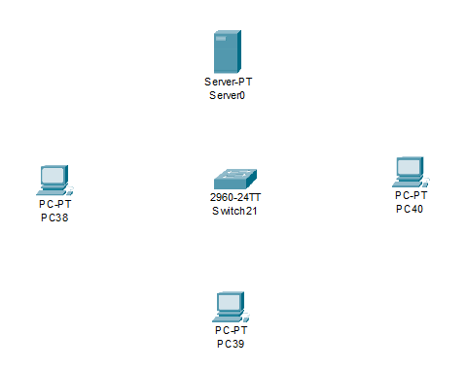

**Step2:** connect fast ethernets from switch to server and switch to PCs

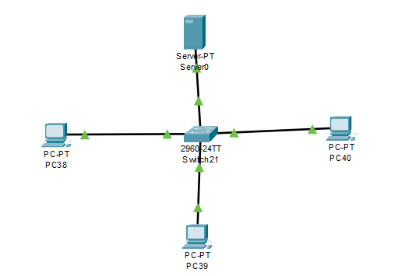

**Step3:** Assign IP address for each PCs

IP address for PC38:192.168.1.7

IP address for PC39: 192.168.1.8

IP address for PC40: 192.168.1.9

**Step4:** allocate the message



**Result:** message sent successfully from PC38-PC40